Punctuation or Special Character Counts

Definition
# Source: AI Source: Provided by: [Data Path: Persons Table -> ID Column: 1, Name_En Column: Motasem Essam] -> From: [ChatGPT] on [12/10/2025]
Punctuation or Special Character Counts are text features that measure the number of punctuation marks or special characters (e.g., !, ., ?, #, @) in a document. These features provide insight into writing style, emphasis, or tone.

Key Idea
# Source: AI Source: Provided by: [Data Path: Persons Table -> ID Column: 1, Name_En Column: Motasem Essam] -> From: [ChatGPT] on [12/10/2025]
The presence and frequency of punctuation or special characters can signal emphasis, sentiment, or formality in text. For example, multiple exclamation marks may indicate strong emotion, while hashtags and mentions are common in social media text.

How It Works
# Source: AI Source: Provided by: [Data Path: Persons Table -> ID Column: 1, Name_En Column: Motasem Essam] -> From: [ChatGPT] on [12/10/2025]
- Preprocess the text (optional: lowercase, remove unwanted characters).
- Identify all punctuation marks or special characters in the text.
- Count occurrences for each character or aggregate counts.
- Use these counts as numerical features for models.

Example
# Source: AI Source: Provided by: [Data Path: Persons Table -> ID Column: 1, Name_En Column: Motasem Essam] -> From: [ChatGPT] on [12/10/2025]
Original text: "Wow! I love data science!!! #AI @OpenAI"
- Counts of selected punctuation/special characters:
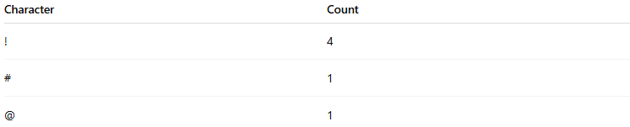
Character | Count
! | 4
# | 1
@ | 1

Applications
# Source: AI Source: Provided by: [Data Path: Persons Table -> ID Column: 1, Name_En Column: Motasem Essam] -> From: [ChatGPT] on [12/10/2025]
- Sentiment analysis (e.g., emphasis or excitement)
- Social media analysis (hashtags, mentions)
- Text classification (spam detection, informal vs. formal text)
- Feature engineering for machine learning models

Advantages
# Source: AI Source: Provided by: [Data Path: Persons Table -> ID Column: 1, Name_En Column: Motasem Essam] -> From: [ChatGPT] on [12/10/2025]
- Simple to compute
- Captures stylistic and emotional cues in text
- Useful for short texts or social media data

Disadvantages
# Source: AI Source: Provided by: [Data Path: Persons Table -> ID Column: 1, Name_En Column: Motasem Essam] -> From: [ChatGPT] on [12/10/2025]
- Does not capture semantic meaning
- Counts alone may be insufficient for complex tasks
- Sensitive to noisy text or inconsistent punctuation usage

